Q-1) Perform the following operations using MongoDB:
1. Create: Insert multiple documents into a collection called employees. Each
document should have the following fields: name, position, and salary.
Insert the following employees:

a. name: "Alice", position: "Manager", salary: 70000
b. name: "Bob", position: "Developer", salary: 55000
c. name: "Charlie", position: "HR", salary: 45000

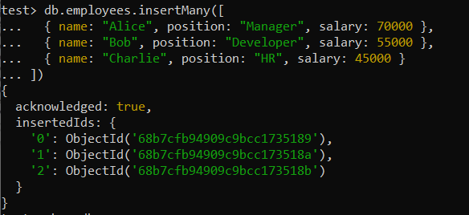

2. Read: Query the employees collection to find all employees with a salary
greater than 50000.

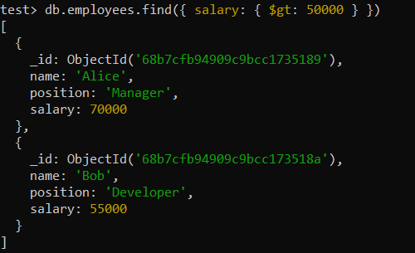

3. Update: Increase the salary of all employees whose position is
"Developer" by 10%.
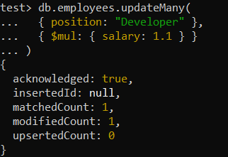

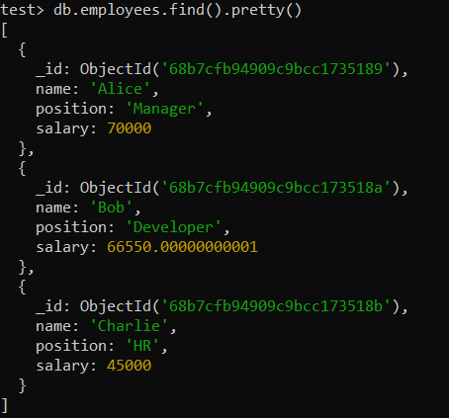

4. Delete: Remove the employee named "Charlie" from the employees
collection.

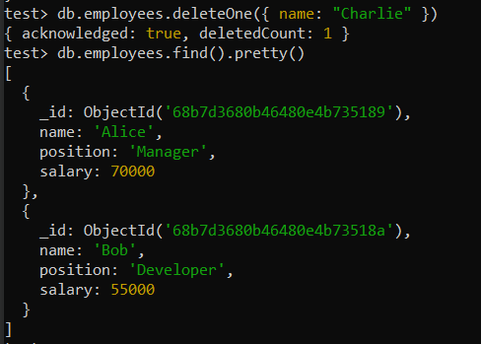
Q-2 Write a MongoDB script to perform the following CRUD operations:
1) Create: Insert a new document into a collection called students. The
document should include the following fields: name, age, and course.
Insert a document with values:
name: "John Doe"
age: 22
course: "Computer Science"

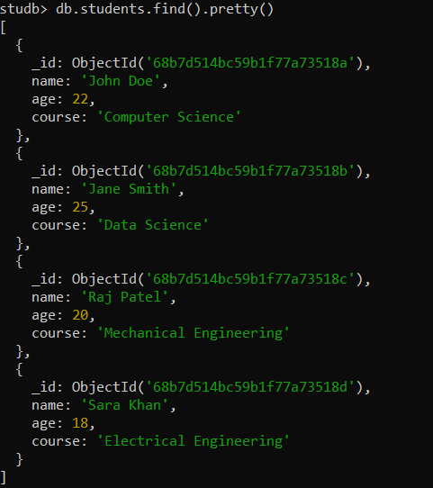

2) Read: Retrieve all documents from the students collection where the age
is greater than 20.
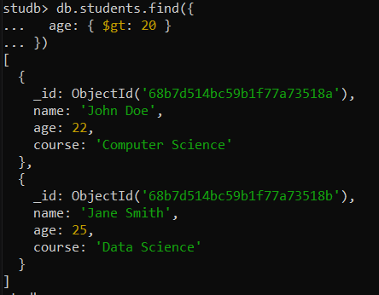

3) Update: Update the course field of the student named "John Doe" to
"Data Science".

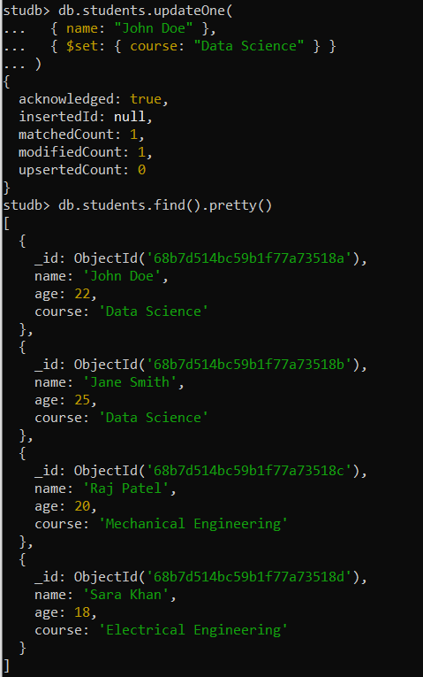

4) Delete: Delete all documents from the students collection where the age
is less than 21.

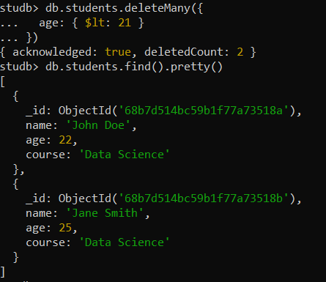

Q-3 Write MongoDB commands to perform the following operations on a collection named books:
1) Create: Insert a document representing a book with the fields title,
author, publishedYear, and copiesSold. Use the following data:
title: "The Alchemist"
author: "Paulo Coelho"
publishedYear: 1988
copiesSold: 65000000

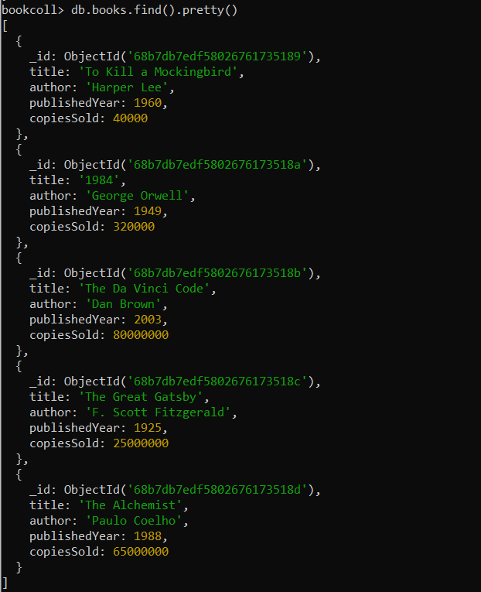

2) Read: Find all books in the books collection that were published before
the year 2000.
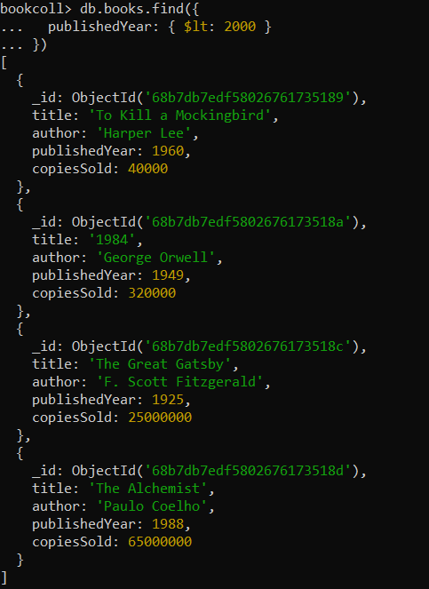

3. Update: Add a new field rating with a value of 4.8 to the document where
the title is "The Alchemist".

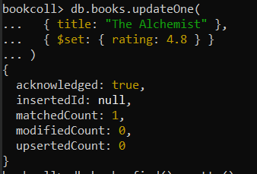

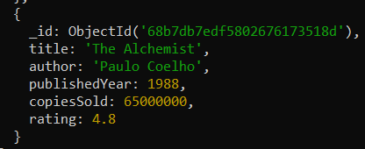

4. Delete all books from the collection where copiesSold is less than

1 million.

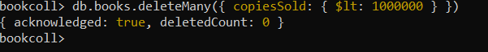

4) Program to calculate average weather temperature of city from csv file.

File : ATCalc
import org.apache.hadoop.conf.Configuration;
import org.apache.hadoop.fs.Path;
import org.apache.hadoop.io.Text;
import org.apache.hadoop.io.IntWritable;
import org.apache.hadoop.mapreduce.Job;
import org.apache.hadoop.mapreduce.lib.input.FileInputFormat;
import org.apache.hadoop.mapreduce.lib.output.FileOutputFormat;

public class ATCalc
{
public static void main(String[] args) throws Exception
{
Configuration conf=new Configuration();
Job job=Job.getInstance(conf,"Average Temperature");

job.setJarByClass(ATCalc.class);
job.setMapperClass(ATMapper.class);
job.setReducerClass(ATReducer.class);

job.setOutputKeyClass(Text.class);
job.setOutputValueClass(IntWritable.class);

FileInputFormat.addInputPath(job,new Path(args[0]));
FileOutputFormat.setOutputPath(job,new Path(args[1]));

System.exit(job.waitForCompletion(true)?0:1);
}
}

File:ATMapper
import java.io.IOException;
import org.apache.hadoop.io.Text;
import org.apache.hadoop.io.IntWritable;
import org.apache.hadoop.mapreduce.Mapper;

public class ATMapper extends Mapper<Object, Text, Text, IntWritable>
{
private Text city=new Text();
private IntWritable temperature=new IntWritable();

@Override
public void map (Object key, Text value, Context context) throws IOException, InterruptedException
{
String[] parts=value.toString().split(",");
if (parts.length==3)
{
city.set(parts[0]);
temperature.set(Integer.parseInt(parts [2]));
context.write(city, temperature);
}

}
}

File:ATReducer
import java.io.IOException;
import org.apache.hadoop.io.Text;
import org.apache.hadoop.io.IntWritable;
import org.apache.hadoop.mapreduce.Reducer;

public class ATReducer extends Reducer<Text,IntWritable,Text,IntWritable>
{
private IntWritable result=new IntWritable();

@Override
public void reduce(Text key,Iterable<IntWritable> values,Context context) throws IOException,InterruptedException
{
int sum=0;
int count=0;
for(IntWritable val:values)
{
sum+=val.get();
count++;
}
int average=sum/count;
result.set(average);
context.write(key,result);
}
}

Output:
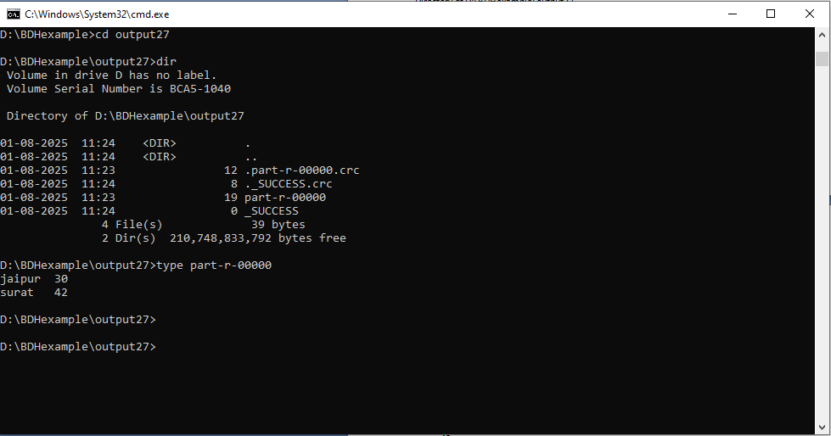

5) Write a MapReduce program that reads a CSV file containing sales transactions with columns: transaction_id, product_id, quantity, and price.
Calculate the total revenue generated for each product and output it as product_id, total_revenue.
SalesRevenueCalc
import org.apache.hadoop.conf.Configuration;
import org.apache.hadoop.fs.Path;
import org.apache.hadoop.io.FloatWritable; // Use FloatWritable for revenue
import org.apache.hadoop.io.Text;
import org.apache.hadoop.mapreduce.Job;
import org.apache.hadoop.mapreduce.lib.input.FileInputFormat;
import org.apache.hadoop.mapreduce.lib.output.FileOutputFormat;

public class SalesRevenueCalc {
public static void main(String[] args) throws Exception {
Configuration conf = new Configuration();
Job job = Job.getInstance(conf, "Product Revenue Calculation");

job.setJarByClass(SalesRevenueCalc.class);
job.setMapperClass(SalesMapper.class);
job.setReducerClass(SalesReducer.class);

job.setOutputKeyClass(Text.class);
job.setOutputValueClass(FloatWritable.class); // Output revenue as FloatWritable

FileInputFormat.addInputPath(job, new Path(args[0]));
FileOutputFormat.setOutputPath(job, new Path(args[1]));

System.exit(job.waitForCompletion(true) ? 0 : 1);
}
}

SalesMapper

import java.io.IOException;
import org.apache.hadoop.io.Text;
import org.apache.hadoop.io.FloatWritable; // Using FloatWritable for revenue
import org.apache.hadoop.mapreduce.Mapper;

public class SalesMapper extends Mapper<Object, Text, Text, FloatWritable> {
private Text product_id = new Text();
private FloatWritable revenue = new FloatWritable();

@Override
public void map(Object key, Text value, Context context) throws IOException, InterruptedException {
String[] parts = value.toString().split(","); // Assuming comma-separated values

// Ensure the line has the expected number of columns (transaction_id, product_id, quantity, price)
if (parts.length == 4) {
try {
String pId = parts[1]; // product_id is the second column (index 1)
int quantity = Integer.parseInt(parts[2]); // quantity is the third column (index 2)
float price = Float.parseFloat(parts[3]); // price is the fourth column (index 3)

product_id.set(pId);
revenue.set(quantity * price); // Calculate revenue for the transaction

context.write(product_id, revenue); // Emit product_id and revenue
} catch (NumberFormatException e) {
// Handle cases where quantity or price are not valid numbers
System.err.println("Skipping bad record: " + value.toString() + " - " + e.getMessage());
}
}
}
}

SalesReducer

import java.io.IOException;
import org.apache.hadoop.io.Text;
import org.apache.hadoop.io.FloatWritable;
import org.apache.hadoop.mapreduce.Reducer;

public class SalesReducer extends Reducer<Text, FloatWritable, Text, FloatWritable> {
private FloatWritable totalRevenue = new FloatWritable();

@Override
public void reduce(Text key, Iterable<FloatWritable> values, Context context)
throws IOException, InterruptedException {
float sumOfRevenue = 0.0f;

// Iterate through all the revenue values for the current product_id
for (FloatWritable value : values) {
sumOfRevenue += value.get(); // Sum up the revenues
}

totalRevenue.set(sumOfRevenue); // Set the total revenue
context.write(key, totalRevenue); // Emit product_id and total revenue
}
}

Output:
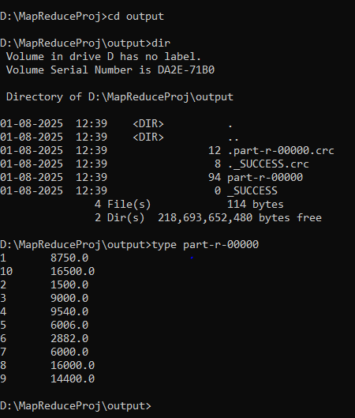

6) Given a CSV file with columns: movie_id, user_id, rating, write a MapReduce program to calculate the average rating for each movie.
Output the results as movie_id, average_rating.

movieCalc

import org.apache.hadoop.conf.Configuration;
import org.apache.hadoop.fs.Path;
import org.apache.hadoop.io.DoubleWritable;
import org.apache.hadoop.io.Text;
import org.apache.hadoop.mapreduce.Job;
import org.apache.hadoop.mapreduce.lib.input.FileInputFormat;
import org.apache.hadoop.mapreduce.lib.output.FileOutputFormat;

public class movieCalc {
public static void main(String[] args) throws Exception {
if (args.length != 2) {
System.err.println("Usage: Calc <input path> <output path>");
System.exit(-1);
}

Configuration conf = new Configuration();
Job job = Job.getInstance(conf, "Movie Rating Average");

job.setJarByClass(movieCalc.class);
job.setMapperClass(movieMapper.class);
job.setReducerClass(movieReducer.class);

job.setMapOutputKeyClass(Text.class);
job.setMapOutputValueClass(DoubleWritable.class);

job.setOutputKeyClass(Text.class);
job.setOutputValueClass(DoubleWritable.class);

FileInputFormat.addInputPath(job, new Path(args[0]));
FileOutputFormat.setOutputPath(job, new Path(args[1]));

System.exit(job.waitForCompletion(true) ? 0 : 1);
}
}

movieMapper

import java.io.IOException;
import org.apache.hadoop.io.DoubleWritable;
import org.apache.hadoop.io.LongWritable;
import org.apache.hadoop.io.Text;
import org.apache.hadoop.mapreduce.Mapper;

public class movieMapper extends Mapper<LongWritable, Text, Text, DoubleWritable> {

private Text movieId = new Text();

@Override
protected void map(LongWritable key, Text value, Context context)
throws IOException, InterruptedException {
String line = value.toString();
String[] fields = line.split(",");

if (fields.length == 3) {
String movie_id = fields[0].trim();
String ratingStr = fields[2].trim();
try {
double rating = Double.parseDouble(ratingStr);
movieId.set(movie_id);
context.write(movieId, new DoubleWritable(rating));
} catch (NumberFormatException e) {
// skip invalid ratings
}
}
}
}

movieReducer

import java.io.IOException;
import org.apache.hadoop.io.DoubleWritable;
import org.apache.hadoop.io.Text;
import org.apache.hadoop.mapreduce.Reducer;

public class movieReducer extends Reducer<Text, DoubleWritable, Text, DoubleWritable> {

@Override
protected void reduce(Text key, Iterable<DoubleWritable> values, Context context)
throws IOException, InterruptedException {
double sum = 0;
int count = 0;

for (DoubleWritable val : values) {
sum += val.get();
count++;
}
if (count > 0) {
double average = sum / count;
context.write(key, new DoubleWritable(average));
}
}
}

Output:-
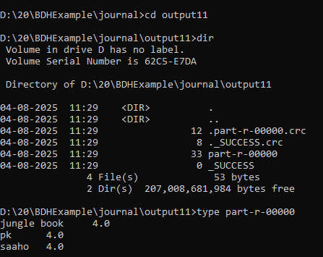

7) Calculating Maximum and Minimum Temperature
Using a weather dataset with columns: city, date, temperature, write a MapReduce program to find the maximum and minimum temperature recorded for each city.
Output the results as city, max_temperature, min_temperature.

MaxMinTempCalc

import org.apache.hadoop.conf.Configuration;
import org.apache.hadoop.fs.Path;
import org.apache.hadoop.io.FloatWritable;
import org.apache.hadoop.io.Text;
import org.apache.hadoop.mapreduce.Job;
import org.apache.hadoop.mapreduce.lib.input.FileInputFormat;
import org.apache.hadoop.mapreduce.lib.output.FileOutputFormat;

public class MaxMinTempCalc {
public static void main(String[] args) throws Exception {
Configuration conf = new Configuration();
Job job = Job.getInstance(conf, "Max Min Temperature");

job.setJarByClass(MaxMinTempCalc.class);
job.setMapperClass(MaxMinTempMapper.class);
job.setReducerClass(MaxMinTempReducer.class);

job.setOutputKeyClass(Text.class);
job.setOutputValueClass(FloatWritable.class);

FileInputFormat.addInputPath(job, new Path(args[0]));
FileOutputFormat.setOutputPath(job, new Path(args[1]));

System.exit(job.waitForCompletion(true) ? 0 : 1);
}
}

MaxMinTempMapper

import java.io.IOException;
import org.apache.hadoop.io.FloatWritable;
import org.apache.hadoop.io.LongWritable;
import org.apache.hadoop.io.Text;
import org.apache.hadoop.mapreduce.Mapper;

public class MaxMinTempMapper extends Mapper<LongWritable, Text, Text, FloatWritable> {

private Text city = new Text();
private FloatWritable temperature = new FloatWritable();

public void map(LongWritable key, Text value, Context context) throws IOException, InterruptedException {
String line = value.toString().trim();
if (line.startsWith("city")) return; // Skip header

String[] parts = line.split(",");
if (parts.length == 3) {
try {
city.set(parts[0].trim());
temperature.set(Float.parseFloat(parts[2].trim()));
context.write(city, temperature);
} catch (NumberFormatException e) {
System.err.println("Invalid temperature: " + line);
}
} else {
System.err.println("Invalid line format: " + line);
}
}
}

MaxMinTempReducer

import java.io.IOException;
import org.apache.hadoop.io.FloatWritable;
import org.apache.hadoop.io.Text;
import org.apache.hadoop.mapreduce.Reducer;

public class MaxMinTempReducer extends Reducer<Text, FloatWritable, Text, Text> {

private Text result = new Text();

public void reduce(Text key, Iterable<FloatWritable> values, Context context) throws IOException, InterruptedException {
float maxTemp = Float.MIN_VALUE;
float minTemp = Float.MAX_VALUE;

for (FloatWritable val : values) {
float temp = val.get();
maxTemp = Math.max(maxTemp, temp);
minTemp = Math.min(minTemp, temp);
}

result.set("Max Temperature: " + maxTemp + ", Min Temperature: " + minTemp);
context.write(key, result);
}
}

Output:-
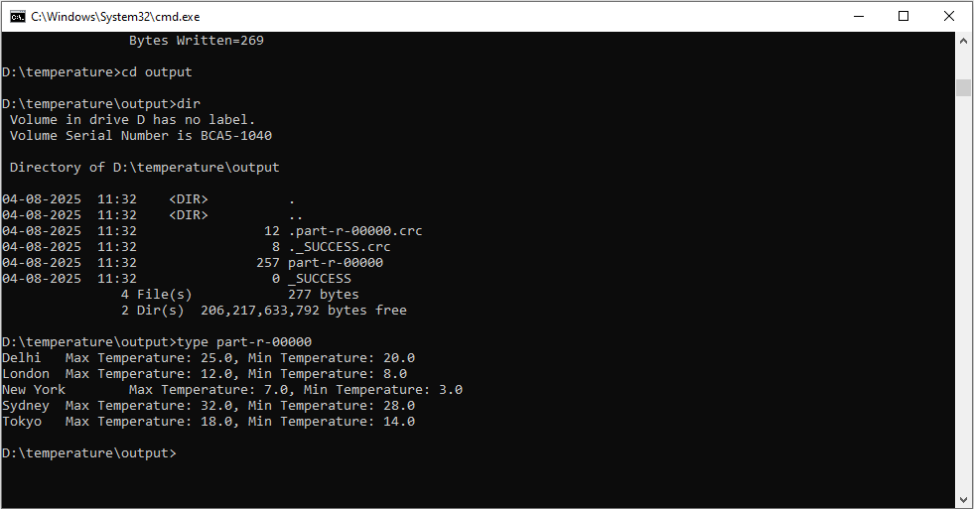

8.Create a database named company_db and within it, create a table called employees with the following columns: employee_id (INT), name (STRING), department (STRING), and salary (FLOAT). Ensure the table stores data in text format.

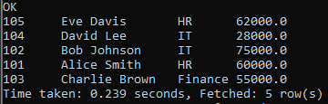

Query:

1. Write a Hive query to retrieve all employee details from the employees table where the department is IT.

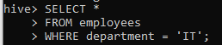

Output:

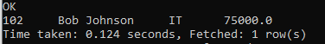

2. Write a Hive query to delete all records from the employees table where the salary is below 30000.
Orignianl Data



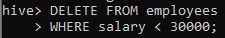

Output:

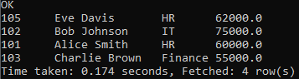

3. Update the location column for all employees whose department is HR to Head Office.

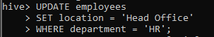

Output:
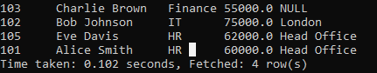

4. Delete the department record where department_id = 3.

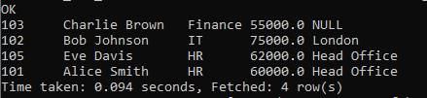

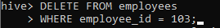
Output:

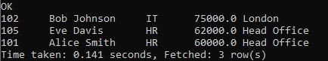

9.Create a database named university_db and within it, create a table called students with the following columns: student_id (INT), name (STRING), course (STRING), and marks (FLOAT). Ensure the table stores data in text format.

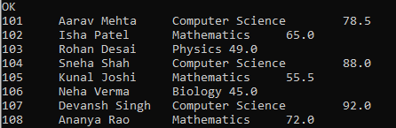

Query:

1. Write a Hive query to retrieve all student details from the students table where the course is Computer Science.

Output:

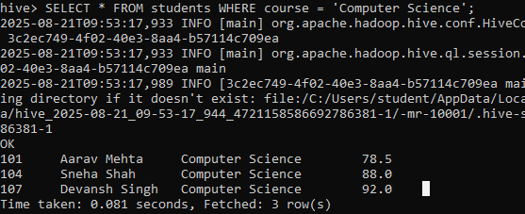

2. Write a Hive query to delete all records from the students table where the marks are below 50.

Output:

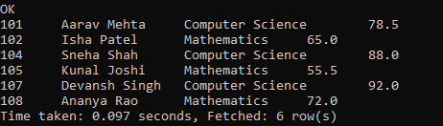

3. Update the marks column for all students whose course is Mathematics by adding 10 bonus points.

Output:

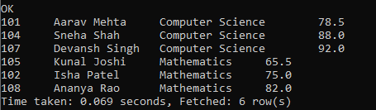

4. Delete the record from the students table where the student_id = 102.

Output:

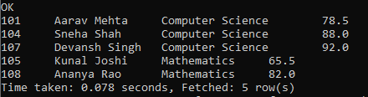

10.Create a database named retail_db and within it, create a table called products with the following columns: product_id (INT), product_name (STRING), category (STRING), and price (FLOAT). Ensure the table stores data in text format.

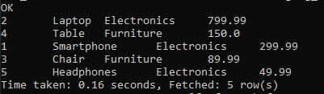

Query:

1. Write a Hive query to retrieve all product details from the products table where the category is Electronics.

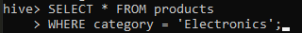

Output:

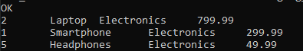

2. Write a Hive query to delete all records from the products table where the price is below 100.

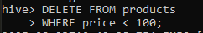

Output:

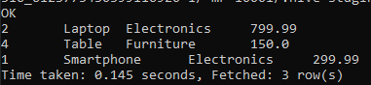

3. Update the price column for all products in the Furniture category by increasing it by 5%.

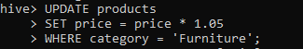

Output:

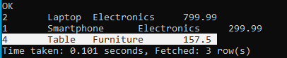

4. Delete the product record from the products table where the product_id = 5.





Output:

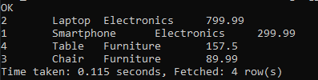

11.Create a database named hospital_db and within it, create a table called patients with the following columns: patient_id (INT), patient_name (STRING), age (INT), and disease (STRING). Ensure the table stores data in text format.

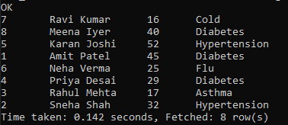

Query:

1. Write a Hive query to retrieve all patient details from the patients table where the disease is Diabetes.

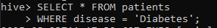

Output:

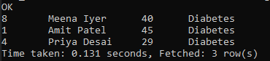

2. Write a Hive query to delete all records from the patients table where the age is below 18.

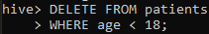

Output:

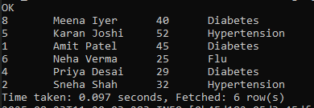

3. Update the disease column for all patients whose disease is Hypertension to Chronic Hypertension.

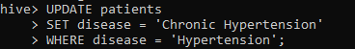

Output:

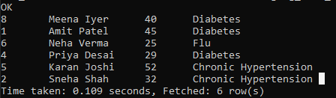

4. Delete the record from the patients table where the patient_id = 8.

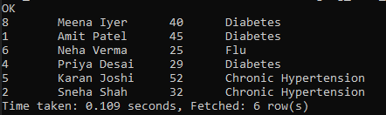

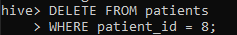

Output:

